STAFF EXPERIENCE FINAL REPORT AND RECOMMENDATIONS

National Staff Experience Project

2011/12/13

CONTENTS

Background 3

Chapter 1: Key Findings 6

Diagram 1: Staff Experience Continuous Improvement Cycle 6

Chapter 2: Outcomes and Recommendations 10

Objective 1 10

Objective 2 11

Objective 3 12

Objective 4 14

Objective 5 15

Appendices 16

Appendix 1 Staff Experience Framework 16

Appendix 2 Final Question Set ‘iMatter’ 17

Appendix 3 Sample ‘iMatter’ Team Results Report and Thermometer 20

Acknowledgements 24

# BACKGROUND

NHSScotland is committed to improving Patient Experience. This commitment led to discussions between the Scottish Government Health Directorate and 3 NHS Boards / pilot sites - NHS Dumfries & Galloway, NHS Forth Valley and NHS Tayside. These discussions developed at senior level and highlighted the opportunity to create a leading edge and holistic approach to defining and measuring the concept of Staff Experience within NHSScotland with the ultimate potential outcome of enhancing Patient Experience. NHS National Waiting Times Centre was also invited to join this project and became a partner as a Special Board.

**Project Objectives**

Our project has the following objectives:

* To research what ‘Staff Experience’ means to our employees and by gaining this deep understanding of the components of Staff Experience develop a definition of a good experience that delivers business benefit to NHSScotland in the form of enhanced Patient Experience, improved healthcare outcomes and greater efficiency & productivity.
* To participate in an SGHD review of the existing Staff Governance Standards and influence their redefinition and alignment to current/future needs, based on the emerging findings of this project.
* To define a series of metrics that will be used to assess where individual NHS Boards lie on the spectrum of good-to-poor ‘Staff Experience’, helping us enhance aspects of Quality Strategy implementation and enriching further the Patient Experience.
* To inform the SGHD approach to developing and delivering the planned 2012 NHSScotland Staff Survey by enriching the approach via the embedding of new engagement metrics and bridging to a more real-time framework for the future.
* To make recommendations for OD diagnostics and interventions that can be developed downstream to help strengthen the ‘Staff Experience’ within the Boards and demonstrate a return on investment.

Project Outcomes achieved and Project Recommendations are included in Chapter 2.

**Literature Review and Long Term Recommendations**

An extensive Literature Review focused primarily on exemplar organisations within the public and private sectors out-with NHSScotland. The objective being the scoping out of the challenges, best practices, and outcomes in relation to Employee Engagement.

The subsequent Long Term Recommendations which evolved from this extensive research in the Literature Review, and which were published on 5th August 2012 ([Link to Literature Review](http://www.knowledge.scot.nhs.uk/media/CLT/ResourceUploads/4020444/Staff%20Experience%20Literature%20Review%20(Final%20Sign%20Off%20Version).doc) and [Link to Long Term Recommendations](http://www.knowledge.scot.nhs.uk/media/CLT/ResourceUploads/4020445/Staff%20Experience%20Long-Term%20Recommendations%20((with%20Exec%20Summary)%20-%2029.6.12.doc)) were in line with the Project Objectives. These indicated the potential for a series of metrics which could be defined and utilised to measure and monitor Staff Experience across all NHSScotland Boards. The metrics had the potential to initiate a range of interventions which could be employed and developed to strengthen Staff Experience, and ultimately demonstrate a tangible return on investment. The process began by mapping the (4) MacLeod Enablers (Leadership / Engaging Managers / Employee Voice / Integrity) with the (2010) Scottish Healthcare Quality Ambitions (Person-centred / Safe / Effective) and the five themes enshrined within the NHSScotland Staff Governance Standard, to create a **Staff Experience Framework**. This composite framework (see Appendix 1) has 20 **Employee Engagement Components** which span the range covered under the aforementioned key themes, and also includes a fifth important theme around organisational and individual wellbeing.

**Co-Production Model**

At each stage of the project it has been a pre-requisite for staff to be involved, both in the development process of a “Bespoke Staff Experience Questionnaire” (working title – branding under development) and in focus groups for feedback on the measurement tools, and throughout the testing period of these tools in order to ensure the creation of a complete co-production model. It has been essential for the authors to utilise local systems and to visit Boards in person to maximise involvement and initiate discussions on the process. Staff have also participated in “Paired Comparison” events to assist and offer views on the development of the Employee Engagement Index (EEI), and make decisions on how this would be achieved. Individual members of staff have offered suggestions for improvement throughout the process - having articulated a sense of ownership in the process rather than feeling they are anonymous ‘donors’ of statistical data.

**Testing the Employee Experience Measurement Tools**

In order to assess the viability of the proposed Employee Experience measurement tools outlined within the Long Term Recommendations a series of tests were proposed within each of the four pilot Boards. To assess the achievability, practicality, and acceptability of proposed measurement tools, a Development Day was convened during which a “Bespoke Staff Experience Questionnaire” was developed by staff, staff side representatives and managers within each of the pilot Boards This inclusive approach allowed the “Bespoke Staff Experience Questionnaire” to be populated with questions that staff found to be of particular relevance from the many options they considered, and again this was an excellent example of co-production.

The Team Vitality and Care Questionnaire (TVCQ) © NHS Tayside was originally developed by Sue Mackie, Senior Nurse Practice Development – Clinical Leadership within NHS Tayside, to give nursing and midwifery teams a measure of their team performance in 6 domains. The results are fed back to each team and then used by the team to develop an action plan supported by their line manager. The focus of the feedback is for improvement or celebration rather than judgement. The TVCQ has been used in over 150 clinical teams in NHS Tayside and experience to date has identified that the TVCQ is most effective when used with operational teams managed by one direct frontline manager. The TVCQ has undergone extensive psychometric tests for validity and reliability supported by the University of Dundee. The Team Vitality and Care Questionnaire Staff Experience (TVCQSE) is a slight adaptation of the original tool to allow a broader reflection of the performance expectations for non-clinical teams. It is envisaged that this tool can be used within operational teams following results from the “Bespoke Staff Experience Questionnaire” to give teams a detailed drill down of the issues, and ultimately ownership, of the areas they need to work on.

These two tools were tested within the four pilot Boards. TVCQSE within NHS Boards Forth Valley, Dumfries & Galloway and National Waiting Times Centre across Pilot Test 01, Pilot Test 02 and Pilot Test 03 to undergo internal validation of the revised version. The “Bespoke Staff Experience Questionnaire” was tested within all four pilot Boards across Pilot Test 01, Pilot Test 02, and Pilot Test 03 and recently also underwent external validation under the auspices of Dr Austyn Snowden and Dr Ewan MacArthur of the University of the West of Scotland (UWS).

The pilot teams have received the results of these evaluations from their OD Leads and have worked together with the OD Leads and their managers to implement action plans to support the process of continuous improvement in relation to Staff Experience.

**The National Staff Survey**

In its current format the National Staff Survey undoubtedly generated information, but the uptake was poor, being in the region of 27%, a sample size that may not be considered robust. The main deficit which was often expressed by staff was that although issues could be identified within a locality or Directorate, the responses to these issues tended to be generic rather than have a specific team focus.

Staff regularly expressed the view that filling in the survey in its usual format offered them no personal sense or expectation of change. For whatever reason, there appeared to be a problem with ownership of the instrument in that it was perceived to be a ‘Management Tool’, as opposed to its actual intended function of allowing staff views to inform the organisation.

The model developed within the Staff Experience Project eliminates the need for such a generalised strategy and can highlight the need for remedial intervention to the core of issues at team level.

# CHAPTER 1: Key Findings

**Staff Experience Continuous Improvement Model**

The final **Staff Experience Model and the consequent Employee Engagement Index** has been validated by the University of the West of Scotland who cited it as being a **world-leading, systemic, systematic and collaborative approach** to creating a **functional Model of Staff Experience.**

The External Validation of the “Bespoke Staff Experience Questionnaire” considered that the sample-size permits the Project’s pilot test results to be directly generalised to NHSScotland in its entirety - there were clear calculations made which established the **NHSScotland Employee Engagement Index** (NHSSEEI) at **69%** **for this sample**, which is similar to that obtained within the last NHSScotland National Staff Survey result in 2010.

It is important to clarify that the “Bespoke Staff Experience Questionnaire”, through generating an Employee Engagement Index Score is only the first step on a journey of the Continuous Improvement Process for staff at all levels.

Diagram 1: The Staff Experience Continuous Improvement Cycle

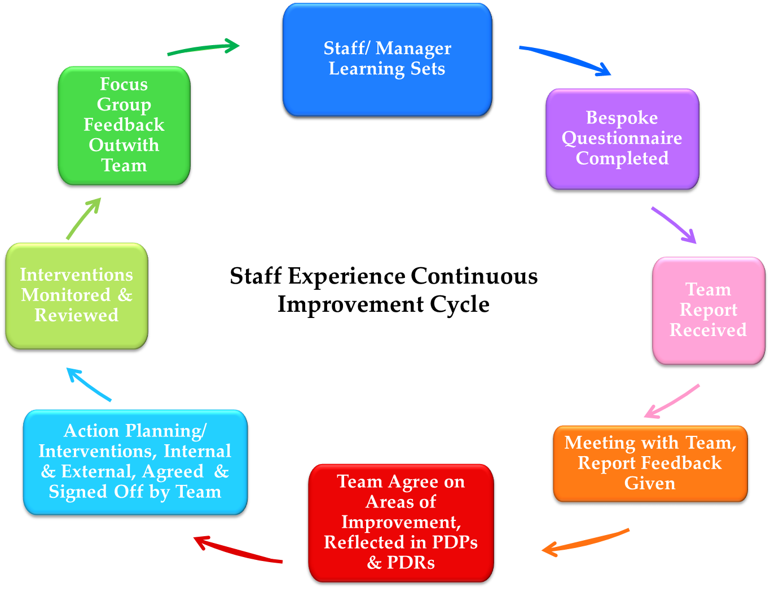

*Staff Experience Continuous Improvement Cycle, Crown Copyright 2013. Contains public sector information licensed under the Open Government License v1.0.*

Adopting this model will allow every Manager, within every team, in every Board across NHSScotland to identify, benchmark, and plan for improvement on an annual basis, and could provide the motivational incentive for teams to constantly exceed their previous results. It also aims to involve every member of staff in the improvement process. Every team would have an individual Employee Engagement Index, which would then be aggregated to establish Directorate, NHS Board and NHSScotland level Employee Engagement Index. Integral to the process, is the local usage of instruments such as the aforementioned TVCQSE and local monitoring and remedial tools such as ‘Pulse Surveys’ to gauge regular progress if required and check for change prior to the next annual round of “Bespoke Staff Experience Questionnaire”. The results from this approach would be sufficiently rigorous and accurate to afford all managers at all levels assurance and accuracy in their planning strategies.

The feedback of resultant outcomes from pilot testing and the application of remedial actions to participating teams has produced positive and evident results. This approach has elicited clear expressions of desire for inclusion in further testing from those managers and teams not initially chosen to participate within the testing process at the three pilot Boards. Further, the four pilot sites have recently submitted a proposal to Scottish Government Health Workforce and Performance Directorate for funding to facilitate a ‘Master Class’ series for Senior Managers on the outputs and benefits unearthed from the National Staff Experience Project.

There have also been requests from other NHS Boards to be considered as ‘early implementers’ within the initial roll-out phase. It is also significant that there has been expression of interest from several NHS teams in England, indicating that this Staff Experience Continuous Improvement Model may be a commercial commodity and income-generating opportunity.

**Scrutiny, Reassurance and Empowerment**

This Project has devised a model of scrutiny, reassurance, and empowerment to deal with many issues and this model has evolved naturally into a stand-alone tool. It has been designed to allow individual teams within NHS Boards across NHSScotland, to **measure** and **benchmark** themselves and then if required plan to **facilitate** *change*. These are the indicators of all high performing teams. Indeed there is clear evidence that links high performing teams with lower rates of patient mortality (West et al 2006)[1].

From a traditional standpoint this approach may seem too sharp a focus in terms of its methodology and outcomes, but with total acknowledgement of the many good, indeed excellent aspects of practice within NHSScotland, it is worth remembering, as Robert Francis Q.C, noted in his (2013)[2] report generated by the Mid Staffordshire NHS Foundation Trust Public Enquiry:

*“It requires a focus on identifying what is wrong”*

*The reference was made in regard to making favourable assumptions unless there was strong evidence**to back it up. The aim of this project is to ensure the ability to* ***evidence our good practice****.*

It is of major significance to note that the Long Term Recommendations from the Staff Experience Project, published some seven months prior to Francis, had already highlighted many of the known contributory factors to good practice.

**Staff Experience Framework Underlying Concepts**

The work of this Project was organised in such a way so as to directly link with the Principles of Staff Governance and therefore with the mutual promotion of the reciprocal rights & responsibilities between employer and employee. This accords with evidence that clearly demonstrates that **a culture of** **constantly improving Employee Engagement** is both beneficial and, **necessary** for **any organisation**.

The concept of the Staff Experience Framework started with published in-depth research which highlighted several key themes which have guided and shaped its development:

* Change must have a specific purpose
* All staff need to buy into the idea at all levels of the organisation - systemic
* Benefits to all have to be clearly explained and highlighted to create involvement, ownership and a sense of empowerment
* There have to be clear and defined reciprocal expectations from all those involved

All of these themes forge a psychological contract within the process and create a sense of mutual purpose.

The model of co-production inherent in the development of this Staff Experience Continuous Improvement Model is in the opinion of the authors completely unrivalled as NHS staff, staff side representatives, management and Scottish Government have been involved in every part of the evolution and development of the process.

**Roll-Out of the Model across NHSScotland**

The Staff Experience Project has already highlighted measurable and specific areas for improvement in the pilot teams which have led to remedial actions to achieve solutions to the **issues** identified by the teams. These have not been costly interventions, but have rather been created “in house” by managers and staff who have taken ownership of the issues to resolve these to improve their working conditions and environment.

It is essential to acknowledge that there is no ‘quick fix’ for rolling out the process across NHSScotland. The benefits, rationale and responsibilities all have to be outlined and fully explained in order to achieve the maximum impact and to create the aforementioned psychological contract between employers and employees. It is proposed that the most effective manner in which to embed the Staff Experience Continuous Improvement Model would be as a **rolling programme,** ensuring buy-in across each of the NHSScotland Boards. This would pave the way to initiate, embed and sustain a programme of **continuous improvement** by the year 2020 in every Board. We should be mindful of course that each Board has its own particular needs and may develop further systems of their own to enhance aspects of the developmental process. Some consideration should also be given as to the required resources for future management and administration of the “Bespoke Staff Experience Questionnaire” and the resultant data analysis to support teams across NHSScotland. An IT package will need to be developed to distribute and undertake automated analysis as part of the roll out phase.

This is a unique opportunity to introduce and sustain real change within every team across every Board of NHSScotland and has been possible only with an ethos of buy-in and co-production and continuous improvement at its very core. Patient Experience and Staff Experience are two essential entities which are intrinsically linked - one cannot maintain its equilibrium without the other.

To maximise **Patient Experience** we must also **maximise Staff Experience** in order to develop and promote a world-leading system of healthcare. We have the potential to markedly improve Staff Experience which will ultimately enhance Employee Engagement, by giving our staff the tools and guidance to enhance their own invaluable skills, and by enabling all staff to feel empowered in changing and shaping the NHSScotland healthcare system.

In conclusion the outcome of this Project provides a **Staff Experience Continuous Improvement Model** which will support the aims and deliverables of the **2020 Workforce Vision.** This model also has the potential to support the delivery of enhanced Patient Experience, improved healthcare outcomes and greater efficiency and productivity within NHSScotland.

# CHAPTER 2: Outcomes and Recommendations

|  |  |
| --- | --- |
| **Objective 1:** | **To research what the ‘Staff Experience’ means to our employees and through this develop a definition and a deep understanding of the components of a good experience that delivers business benefit to NHSScotland (e.g. enhanced Patient Experience, improved healthcare outcomes, efficiency & productivity)** |
| **Outcomes** | * Permission was sought and given by the creator of MacLeod definition to approve its use as the Staff Experience definition for NHSScotland;   *“A workplace approach designed to ensure employees are committed to* ***their organisation’s goals and values****, motivated to* ***organisation success****, and are able at the same time to enhance* ***their own sense of well-being****”[3]*   * From the collation of narrative and data from focus groups and the information gathered from exemplar organisations and the Literature Review, a **Staff Experience Continuous Improvement Model** (Diagram 1) has been developed which houses; the **Staff Experience Framework** (see Appendix 1), a final set of **20 Employee Engagement Components** aligned to the Staff Governance Standard, the MacLeod Enablers and The Healthcare Quality Strategy 2010 3 Ambitions, Staff Experience metrics, and a developing Staff Experience toolkit. |
| **Recommendations** | * The NHSScotland Staff Experience definition and the Staff Experience Continuous Improvement Model are approved by Scottish Workforce and Staff Governance Committee (SWAG) * To procure the development of a bespoke IT software package to distribute and undertake automated analysis * NHS Boards adopt the NHSScotland Staff Experience definition * NHS Boards adopt the Staff Experience Continuous Improvement Model * To agree and develop a corresponding set of National Employee Engagement Standards in Phase 2 of the Project * To agree and develop National NHSScotland Management Development Framework in Phase 2 of the Project |

|  |  |
| --- | --- |
| **Objective 2:** | **To participate in an SGHD review of the existing Staff Governance Standards and influence their redefinition and alignment to current/future needs based on the emerging findings of this project** |
| **Outcomes** | * SGHD review of the existing Staff Governance Standard was supported by and linked to the Staff Experience Framework and Components * Influenced amendments to the Staff Governance Strands in particular the inclusion of Wellbeing |
| **Recommendations** | * SAAT review reflects the NHSSEEI score for each Board * The SAAT review should reflect the SE Framework in particular the SE components as well as the outcomes of “Bespoke Staff Experience Questionnaire” team results linked into the Staff Governance Standard * The SAAT submitted by each NHS Board should show the correlation between the evidence included and the results from the “Bespoke Staff Experience Questionnaire” * Independent Staff Governance focus groups should be held within each NHS Board to further validate Staff Experience |

|  |  |
| --- | --- |
| **Objective 3:** | **To define a series of metrics that will be used to assess where individual NHS Boards lie on the spectrum of good-to-poor ‘Staff Experience’, helping us enhance aspects of Quality Strategy implementation and enriching further the Patient Experience** |
| **Outcomes** | * Development of a “Bespoke Staff Experience Questionnaire” (Appendix 2) which includes an NHSScotland Employee Engagement Index (NHSSEEI)   The “Bespoke Staff Experience Questionnaire”, together with the results of Pilot 3 and the NHSSEEI has been **validated** by University West of Scotland (UWS)4[4]  *“The NHSSEEI is a robust, reliable, valid and popular measure of staff engagement. It is also an excellent tool to measure improvement in staff engagement”* 4  *“This final report details the responses from pilot 3, consisting of responses from 1,271 staff from 3 Boards: NHS Golden Jubilee, NHS Forth Valley and NHS Tayside. As a result of this excellent sample size we can be confident the* ***results*** *presented here should be* ***generalisable to all NHSScotland employees****”* 4   * Development of a complete co-production model for “Bespoke Staff Experience Questionnaire”   *“Built in conjunction with NHSScotland staff, Scotland is the only country in the world to be developing such a systematic measure in this inclusive manner”* 4   * Team Vitality and Care Questionnaire Staff Experience (TVCQSE) NHS Tayside (Mackie) and Scottish Government, currently undergoing validation NHS Tayside supported by Dundee University, to be used as a recommended national team diagnostic tool at local level * Further development of a National Staff Experience Diagnostic Toolkit which includes Pulse Surveys and Exit Interviews in line with the Staff Experience Framework and “Bespoke Staff Experience Questionnaire” * The branding for the “Bespoke Staff Experience Questionnaire” was voted for and agreed as ‘iMatter’ |
| **Objective 3:** | **To define a series of metrics that will be used to assess where individual NHS Boards lie on the spectrum of good-to-poor ‘Staff Experience’, helping us enhance aspects of Quality Strategy implementation and enriching further the Patient Experience** |
| **Recommendations** | * SWAG to approve the “Bespoke Staff Experience Questionnaire” including the formula for the calculation of the NHSSEEI * SWAG to approve the Staff Experience Team Results Reports developed from the “Bespoke Staff Experience Questionnaire” with the thresholds for results visually set on a colour coded rating scale at Focus to Improve 0-33% (**Red**), Improve to Monitor 34-50%, (**Orange**), Monitor to Further Improve 51-66% (**Yellow**), and Strive and Celebrate 67-100% (**Green**) (a sample Team results Report can be found in Appendix 3) * SWAG to approve the Team Vitality and Care Questionnaire Staff Experience (TVCQSE) |

|  |  |
| --- | --- |
| **Objective 4:** | **To inform the SGHD approach to developing and delivering the planned 2012 NHSScotland Staff Survey, by enriching the approach through the embedding of new engagement metrics and bridging to a more real-time framework for the future** |
| **Outcomes** | * A “Bespoke Staff Experience Questionnaire” developed as part of the Staff Experience Continuous Improvement Model * The production of a validated NHSSEEI metric |
| **Recommendations** | * SWAG to consider the future roll out and implementation of the Staff Experience Continuous Improvement Model including the “Bespoke Staff Experience Questionnaire” and NHSSEEI as Phase 2 of the Project. Expressions of interest have been received from several NHS Boards who wish to be early implementers * Staff Experience Continuous Improvement Model to be initially rolled out from Autumn 2013 through 2016 * Staff Experience Continuous Improvement Model embedded to support the deliverables and aims of the 2020 Workforce Vision * To map the existing National Staff Survey questions with the Externally Validated “Bespoke Staff Experience Questionnaire” set of questions |

|  |  |
| --- | --- |
| **Objective 5:** | **To make recommendations for OD diagnostics and interventions that can be developed downstream to help strengthen the ‘Staff Experience’ within the Boards and demonstrate a return on investment** |
| **Outcomes** | * To submit a proposal to SWAG which will support the roll out and implementation of Phase 2 of the Staff Experience Continuous Improvement Model. This proposal to include the undernoted recommendations |
| **Recommendations** | * Development of a National Staff Experience Toolkit linked to the Staff Experience Continuous Improvement Model in order to promote a systemic approach   Development of tools to be included within the National Staff Experience Toolkit;   * A sample of Pulse Surveys e.g. Health and Wellbeing, Equality and Diversity, linked back to the Staff Experience Framework and developed to link in to a relevant Staff Governance Strand * Exit Interviews aligned to the NHSSEEI * Tools which NHS Boards are currently using to improve levels of Employee Engagement * Further development of Healthy Working Lives Health & Wellbeing Assessment Tool, Wellness Project, Professionalism, RCN Principles and Values Based Reflective Practice aligned to the Staff Experience Framework * Development of National Management Development Framework e.g. Managers Passport, Personal Resilience and Wellbeing * To commission a piece of academic research commencing April 2016 to evaluate the impact of the roll out and implementation of the Staff Experience Continuous Improvement Model * To develop a ROI study of the Project demonstrating how the return on investment from continuous improvement of Staff Experience. |

APPENDICES

Appendix 1 – Staff Experience Framework



*Staff Experience Continuous Improvement Framework, Crown Copyright 2013. Contains public sector information licensed under the Open Government License v1.0.*

Appendix 2 – Final Question Set ‘iMatter’

|  |  |
| --- | --- |
| Staff Experience Bespoke Questions | Staff Experience Employee Engagement Components |
| My direct line manager is sufficiently approachable | **Visible and Consistent Leadership** |
| I feel senior managers responsible for the wider organisation are sufficiently visible | **Visible and Consistent Leadership** |
| I understand how my role contributes to the goals of my organisation | **Sense of Vision, Purpose and Values** |
| I am clear what my duties and responsibilities are | **Role Clarity** |
| I get the information I need to do my job well | **Clear, Appropriate and Timeously Communication** |
| I am given the time and resources to support my learning and growth | **Learning and Growth** |
| I get enough helpful feedback on how well I do my work | **Performance Development and Review** |
| I have sufficient support to do my job well | **Access to Time and Resources** |
| I feel appreciated for the work I do | **Recognition and Reward** |
| I have confidence and trust in my direct line manager | **Confidence and Trust in my management** |
| I have confidence and trust in senior managers responsible for the wider organisation | **Confidence and Trust in my management** |
| I am confident my ideas and suggestions are listened to | **Listened to and Acted Upon** |
| I am confident my ideas and suggestions are acted upon | **Listened to and Acted Upon** |
| I feel involved in decisions relating to my organisation | **Partnership Working** |
| I feel involved in decisions relating to my job | **Empowered to influence** |
| I feel involved in decisions relating to my team | **Empowered to influence** |
| I am treated with dignity and respect as an individual | **Valued as an Individual** |
| My team works well together | **Effective Team Working** |
| I am treated fairly and consistently | **Consistent Application of Employment Policies and Procedures** |
| I am confident performance is managed well within my team | **Performance Management** |
| I am confident performance is managed well within my organisation | **Performance Management** |
| I get the help and support I need from other teams and services within the organisation to do my job | **Appropriate Behaviours and Supportive Relationships** |
| My work gives me a sense of achievement | **Job Satisfaction** |
| I feel my direct line manager cares about my health and well being | **Assessing Risk and Monitoring Work Stress and Workload** |
| I feel my organisation cares about my health and well being | **Health and Wellbeing Support** |
| I would recommend my team as a good place to work | **Additional Question** |
| I would recommend my organisation as a good place to work | **Additional Question** |
| I would be happy for a friend or relative to access services within my organisation | **Additional Question** |

*‘iMatter’ Question Set, Crown Copyright 2013. Contains public sector information licensed under the Open Government License v1.0.*

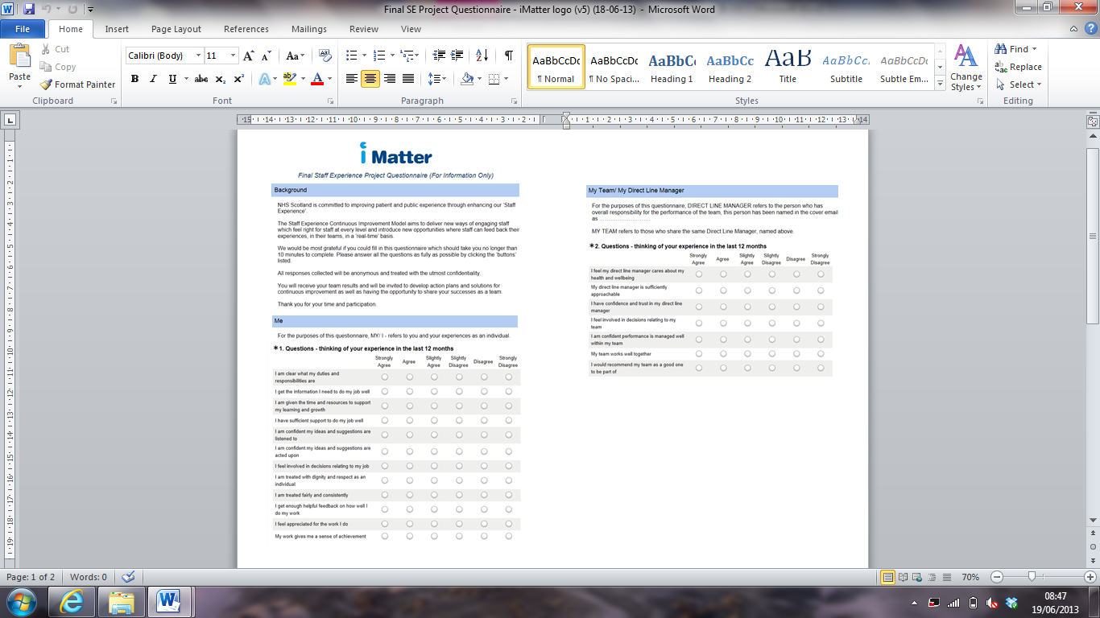

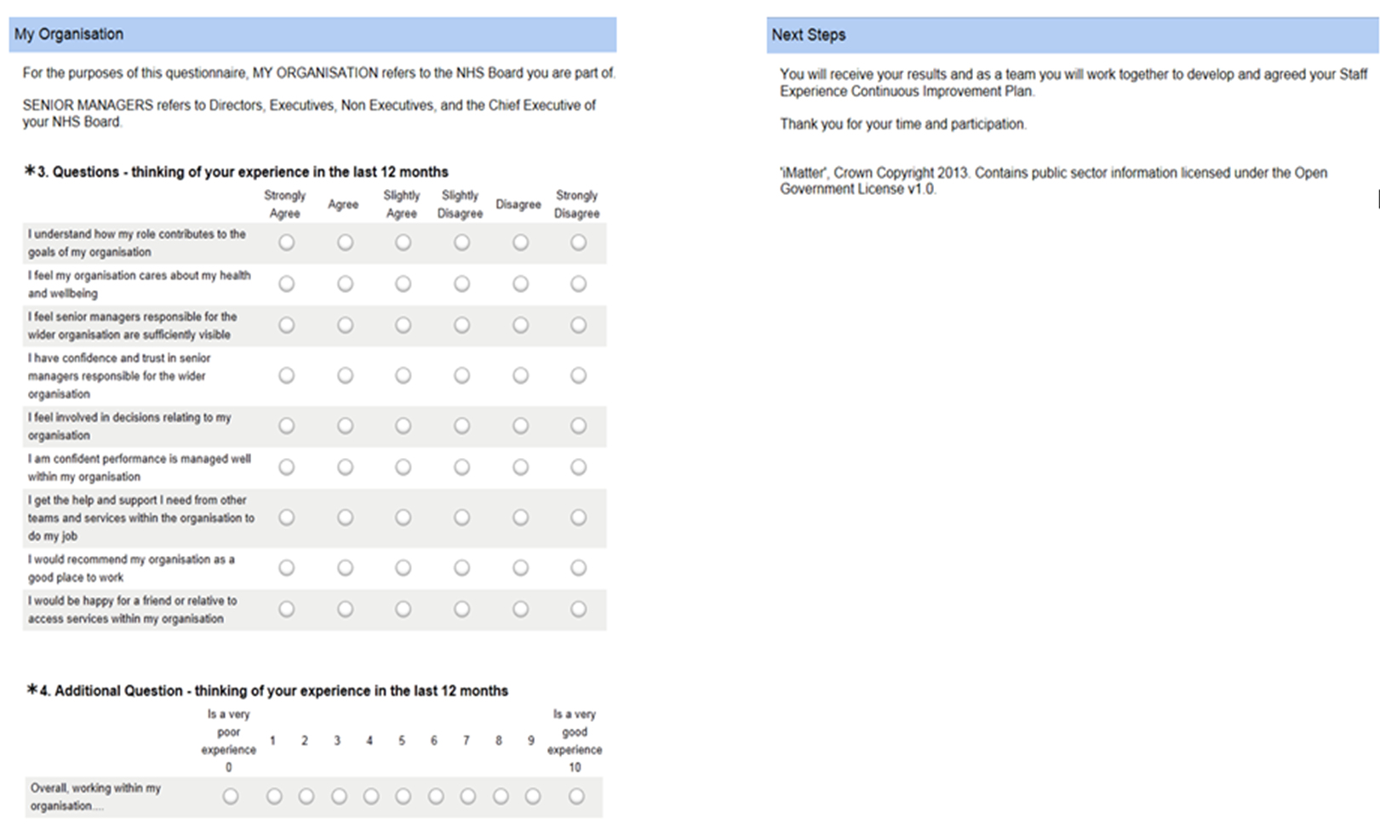

Appendix 3 – Sample ‘iMatter’ Team Results Report and Thermometer







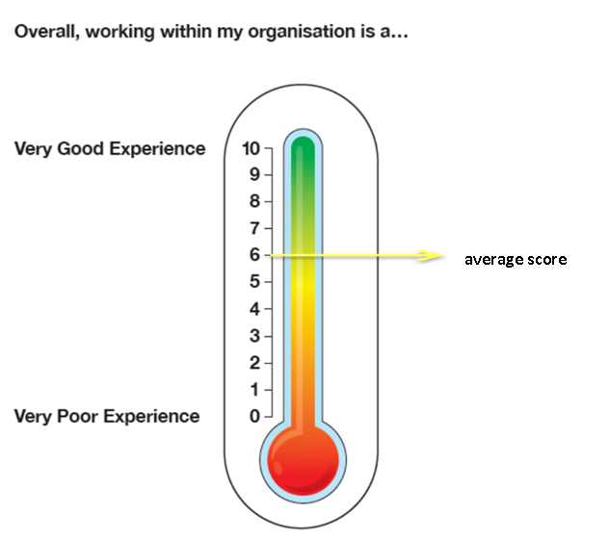

*‘iMatter’ Results Report, Crown Copyright 2013. Contains public sector information licensed under the Open Government License v1.0.*

Acknowledgements

Acknowledgement and Contribution of;

The Staff Experience Project Team - John Davidson (chair) – Head of Human Resources, NHS Scottish Ambulance Service

Liz Reilly – Staff Experience Project Manager

Rachael Harkness – Staff Experience Project Analyst

Morag McLaren - Associate Director of Human Resources, Organisational Development & Learning (NHS Forth Valley)

Cathy Fox – Head of Organisational Development (NHS National Waiting Time Centre)

Sandy Wilkie – Head of Organisation Development (Dumfries & Galloway)

Diane McLeish – Organisational Development Consultant (NHS Tayside)

David Miller – Head of Human Resources (NHS National Waiting Time Centre)

Tom Hart – Employee Director (NHS Forth Valley)

Judith Golden – Employee Director (NHS Tayside)

Jimmy Beattie – Employee Director (NHS Dumfries & Galloway)

Jane Christie - Employee Director (NHS National Waiting Time Centre)

Anne Benton – Organisational Development Advisor (NHS Forth Valley)

Heather Strachan – Senior Research Fellow (Glasgow Caledonian University)

Anne Campbell – National KSF Lead

Darren Paterson – 2020 Workforce Vision Project Manager (Governance and Engagement)

Aileen McIntosh – Health Finance & Information Directorate

The Staff Experience Project Steering Group - Caroline Sharp (chair) – Director of Workforce (NHS Dumfries & Galloway)

Helen Kelly – Director of Human Resources (NHS Forth Valley)

George Doherty – Director of Human Resources (NHS Tayside)

Lindsey Ferries – Director of Human Resources (NHS National Waiting Time Centre)

Ros Derham – Staff Side Rep (Royal College of Nursing)

Sarah Duncan – Staff Side Rep (Unison)

Gillian Costello - Associate Director of Nursing (NHS Tayside)

Additional Acknowledgement of ; Sue Mackie – Senior Nurse Practice Development – Clinical Leadership (NHS Tayside)

Dr Austyn Snowdon – Reader in Mental Health (University of West of Scotland)

Dr Ewan MacArthur – Senior Lecturer in Mathematics (University of West of Scotland)

Jenny Gordon – Research and Innovation Manager (Royal College of Nursing – critical friend)

Colleagues from SWAG

1. West, M,A., Guthrie, J, P., Dawson, C, S., and Carter, M., (2006) Reducing Patient Mortality in Hospitals: The Role of Human Resource Management. Journal of Organisational Behaviour, 27, pp.983-1002
2. Francis, R (2013) Mid Staffordshire NHS Foundation Trust Public Enquiry
3. MacLeod, D. Clarke, N. (2009) Engaging for Success: Enhancing Performance through Employee Engagement
4. 4 Snowden, A & MacArthur, E (2013) Validation of the NHSScotland Employee Engagement Index: Final Report