Workforce Directorate Update Paper
NOVEMBER 2014

CIRCULATION:
All Executive Directors & General Managers - for onward circulation to teams.

ITEMS:

- Occupational Health ..................................................................................... 1
- Professional Registrations ........................................................................... 3
- Staff Survey – Final Information .................................................................. 3
- Diarrohea and Vomiting .............................................................................. 5
- Recruitment Line ......................................................................................... 6

1. OCCUPATIONAL HEALTH

Standard Operating Procedure for Management of Needlestick/Sharp
and other Blood Borne Virus Exposure Incidents in NHS Staff

This revised document is available on the Occupational Health & Safety folder on Hippo.

Please note: the National Infection Prevention and Control Manual provides over arching mandatory guidance for NHS employees in the event of an Occupational Blood Borne Virus exposure incident (Chapter 1, Section 1.10 and Appendix 13).

The purpose of this document is to provide all NHS Dumfries and Galloway staff local advice and guidance on Needle/Sharp injury or Blood Borne Virus (BBV), exposure prevention and the action/procedure to be followed by all staff in the event of such an incident.

In the event of any queries please contact Heather Aitchison, Specialist Practitioner Occupational Health,
Ext 34626 or heatheraitchison@nhs.net

Respiratory Mask (FFP3) Fit Testing

As you are aware we are entering the winter season and I would like to take this opportunity to stress the importance that all those staff working in high risk areas must be fit tested for FFP3 respirator masks.

Unfortunately I must add that staff previously tested for the 3M 1863 or 1873 (with valve) will require repeat testing as I have been made aware that 3M have replaced these masks with a plus version 1863+ and 1873+ (with valve).

There may be some old stock in circulation but I would expect these will be running low, any new stock now is likely to be the plus version.

Any staff who require assessor or refresher training please note there is only one session left for 2014 at the Education Centre on the 21 Nov (1-3pm).

Please contact Occ Health if you cannot make this and we will endeavour to arrange an alternative.

Equally if you have any queries or concerns regarding fit testing please do not hesitate to contact me.

See Respiratory Mask Fit Test Policy on Hippo – Services – Workforce Directorate - Health & Safety Policies.

NHS Dumfries and Galloway have converted to

BD Venflon Pro Safety Cannula
BD was awarded the contract for the West Coast of Scotland.
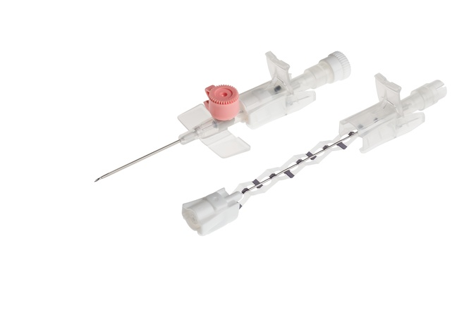
Implementation commenced week of 6 October 2014 throughout NHS D&G

The BD Representative has been on site at
DGRI and GCH (pm)
to demonstrate the features and benefits of the cannula.

Should you have any continuing concerns or queries please contact:

Lorna Methven (BD Local Contact)
07899 662783 Lorna_Methven@europe.bd.com

OR

Heather Aitchison, Specialist Practitioner Occupational Health, heatheraitchison@nhs.net, Ext: 3462

2. PROFESSIONAL REGISTRATIONS

Please can managers remind all professionally registered staff that they must keep their name and address details current with their Professional Body and renew their registration in good time. This is because following the introduction of the latest version of the Professional Registration Policy in August 2013, the Board is still identifying individuals who fail to renew their registration on time. The policy emphasises that it is each individual employee’s responsibility to ensure his or her registration with a professional/regulatory body remains current at all times.
The Nursing and Midwifery Council (NMC) can take up to 10 working days to process renewal documentation upon receipt of payment (and they provide 45 days notice if a renewal is required). The General Dental Council requires all registrations to be renewed on the 1st of January so has a huge backlog at this time. So please do not delay your renewal.
Line managers are reminded that HR.Net must be updated with the renewal information following a check of the professional body’s website. Full details of line management responsibilities are in the Policy document available on HIPPO within the Workforce Directorate / Human Resources / Policies folders.
The Policy is clear that where professional registration is a condition of employment, and a member of staff allows their registration to lapse, they are no longer able to work in the capacity for which they are employed. They will not be permitted to work and will not receive payment for the period they are not registered. However in circumstances where there is evidence produced that confirms this is an error wholly on the part of the professional registration body, then these will be dealt with on an individual basis with the local Manager and HR Support.

3. STAFF SURVEY – FINAL INFORMATION

Please note that a more detailed report is due before the end of this year.

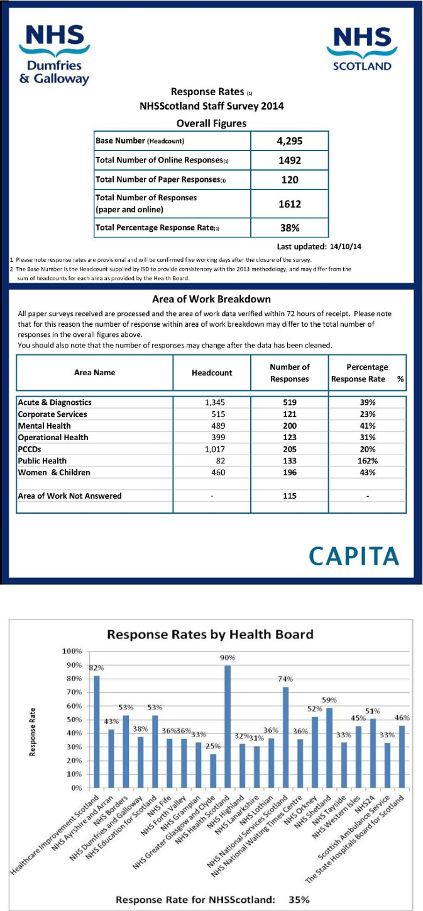

4. DIARRHOEA AND VOMITING

Managers and staff should note that anyone reporting with symptoms of D&V should be advised not to come into work. When the symptoms have resolved i.e. after the last episode of vomiting or diarrhoea, they must be excluded from work for a further 48 hours.

For example, if an individual has symptoms for 2 days he/she must be excluded from work for a further 48 hour period. The absence totals 4 days, 2 of which should be recorded as sickness absence and 2 as medical exclusion. Medical exclusion or suspension from work is where an individual for infection control or patient safety purposes is advised to remain at home, when otherwise they would be fit to come into work. Exclusion does not affect pay. The staff member should be asked to contact OH who will issue the medical exclusion certificate.

Staff may be asked to submit a specimen.

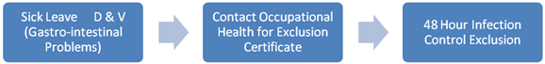

To record an exclusion from work on SSTS, please enter this under 'absence type' - as 'infection control'.

SSTS should be shown with 2 separate absence types entered, but also the Occupational Health contact box for both should be checked and certificate filed in the employees personnel file.
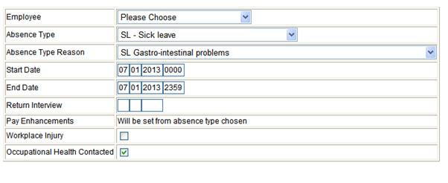It may also be worthwhile noting that if you are on Sick Leave and then days off, the days off may cover the requirement for the 48 hour infection control exclusion.

5. RECRUITMENT LINE

The dedicated recruitment helpline (ext: 32757) has been discontinued and this number has now been reallocated to another member of staff in the organisation.

The line was discontinued as we have moved away from posting out application packs with applicants now able to access packs and application forms via the SHOW website

Packs and application forms can be access by using the following links:

Vacancies open to current NHS Dumfries & Galloway employees ONLY - https://jobs.scot.nhs.uk/intvac/Results.aspx?regionID=5
Vacancies open to all (advertised on the SHOW and Job Centre websites) - https://jobs.scot.nhs.uk/_results.aspx?catID=&regionID=5&orgID=&word=

General recruitment enquiries can still be made by contacting us on dg.recruitment@nhs.net

