Workforce Directorate Update Paper
DECEMBER 2014

CIRCULATION:
All Executive Directors & General Managers - for onward circulation to teams.

ITEMS:

- A New NHS Pension Scheme ..................................................................... 1
- Holiday Pay ................................................................................................. 3
- Date Protection Requests ........................................................................... 3
- Special Leave Policy ................................................................................... 4
- Sickness Absence Update .......................................................................... 4
- eESS Update .............................................................................................. 5
- Equality & Diversity ..................................................................................... 6
- Modern Apprentices .................................................................................... 6
- Retirement Policy Update ........................................................................... 7
- Adverse Weather ........................................................................................ 7
- Occupational Health ................................................................................... 8

1. A NEW NHS PENSION SCHEME

You may not have heard but the NHS Pension Scheme, in line with other public pension schemes, will change from 1 April 2015. All those joining the scheme for the first time along with members of the current arrangements who do not fall within the protected group will transfer to this new Scheme.

What is different about the new scheme?

The new scheme will no longer be a final salary arrangement (i.e. pension based on the member’s pensionable pay and length of scheme membership at the time of retirement), but will be based on a proportion (1/54th) of the member’s pensionable earnings each year. The pension will be the sum of each year’s value built up over the length of the member’s career and revalued each year in line with the rate of inflation (plus 1.5% for as long as a member continues to pay contributions). This is called a Career Average Revalued Earnings or “CARE” scheme and further information on how it works is available on the Scottish Public Pensions Agency (SPPA) website at www.sppa,gov.uk. The other main difference in the new scheme is that the normal pension age will no longer be fixed at a set age, but will be linked to the member’s individual state pension age.

Which members are protected?

Members who were within 10 years of their current normal pension age at 1 April 2012 will remain in their current section of the scheme and not have to move to the new 2015 scheme. Some members who were within a further 3 years 5 months of their current normal pension age at 1 April 2012 will have some protection (known as “tapered protection”) but will have to move to the 2015 scheme at a later date. Again further information on “protection” is available on the SPPA website.
Can members choose to opt out of protection?

Those entitled to Protection in the 2008 section will be given an opportunity sometime after 1st April 2015 to opt out of Protection if they wish. This option will be offered because for some members it is possible that if they do not receive promotional pay increases before retirement that the higher accrual rate in the 2015 arrangement could deliver a bigger pension than the 2008 section. Further information will be issued to those affected after 1 April 2015.

What happens to the pension a member has accumulated in the current scheme?

Whether a member moves to the new scheme on 1 April 2015 or later, the pension benefits already built up in the 1995 and 2008 sections of the previous scheme will be unchanged and calculated on the member’s final pay at or near retirement. A member can retire and claim his/her pension accrued in the old scheme without reduction for early payment once the member reaches the current normal pension age for the relevant section of that scheme (age 55, 60 or 65).

If a member does decide to retire from the 1995 section they will not be able to continue in the 2015 scheme. (Except for those who have been out of the scheme for 5 years or more, as they will have lost their link to final salary at the time of retirement). They will then have the option of either leaving their 2015 benefits and claiming them at state pension age or taking them at a reduced level. For those in the 2008 section who retire and take their benefits from that section, they will be able to re-join the 2015 scheme. Again though, if they take 2015 benefits before state pension age those benefits will be reduced.

What about the choice exercise that happened in 2010?

The original Pension Choice Exercise which took place in 2010 enabled 1995 section members who were expecting to stay in the NHS Pension Scheme and retire close to age 65 or later, to gain an expectation of a higher pension if they transferred to the 2008 section. In transferring to the 2008 section they could convert all of their existing 95 section service to pensionable service in the 2008 section. Now that the landscape has changed it has been decided that those who were previously eligible for “choice” and decided not to transfer to the 2008 section at that time should be given the opportunity to consider this again. This is because some people may have made a different decision had they realised that in the future their normal pension age would be linked to state pension age. When this will happen has yet to be decided but those affected will be contacted at the relevant time by SPPA.
When will members receive further information?
There is currently information available on the SPPA website at www.SPPA.gov.uk . This will be expanded as communication products are developed. SPPA, NHS Employers and Trade Unions are currently developing communication strategies for cascading information to members. New Scheme guides are expected to be available from early 2015.

2. HOLIDAY PAY

You will be aware of recent cases in relation to how holiday pay is calculated.

The Secretariat of the Scottish Terms and Conditions Committee (STAC) recently discussed this and are aware that employers have been approached by staff, staff representatives and other bodies in relation to how these cases may impact on NHS staff. In order to ensure that there is equity in approach by all Health Boards across NHS Scotland, STAC have established a short-life working group to consider this in detail.

If you receive a grievance from a member of staff in relation to this issue, the staff member should be advised that this issue is being considered within national terms and conditions discussions.

3. DATA PROTECTION REQUESTS

To all line managers.

If you receive a request for an individual member of staff to access personal information that is held in their Personal File and this request can reasonably be construed as request under the Data Protection Act, we should be providing a form to the individual member of staff to complete and then return to the Data Protection Officer. However, it is not essential for an individual who wants to request access to this information to use the standard form; they could also write the details of the request down using a different format.

The standard forms are currently available on HIPPO under Documents / Browse Documents / Operational Services / IM&T / Data Protection Guidance.

To ensure any requests can be met as quickly as possible, good housekeeping of Personal Files is essential. Please be reminded that there is a ‘Personal Files - How To Store Employee Information Guide’ on Hippo to provide you with information on what should and should not be retained.

4. SPECIAL LEAVE POLICY

At section:
4.5 OTHER TYPES OF SPECIAL LEAVE

Definition

Another type of special leave is where an organisation is required to make available special leave with pay for staff to be absent from work to perform ‘essential civic and public duties’. The legislative requirement for this is contained within the Employment Rights Act 1996 and covers a wide range of circumstances one of which is:

- Attendance at court as a witness

Please note that for this category of leave, ‘evidence of formal citation must be provided by the employee to the manager who signs off special leave’

5. SICKNESS ABSENCE UPDATE

- National Sickness Absence Data – Published at September 2014

 | Total Hours Lost | Total Contracted Hours | Rate | August 14 Rate | Rate Difference Sep v Aug | WTE Hours Available as % Hours Worked | Cash Equivalent as % Paybill
Scotland | 1,089,415.28 | 22,380,270.99 | 4.87 | 4.70 | 0.17 | -235.5 | -732,211.75
NHS Dumfries & Galloway | 28,940.18 | 577,715.97 | 5.01 | 4.72 | 0.29 | -10.2 | -32,568.37

- NHS D&G Directorate Absence

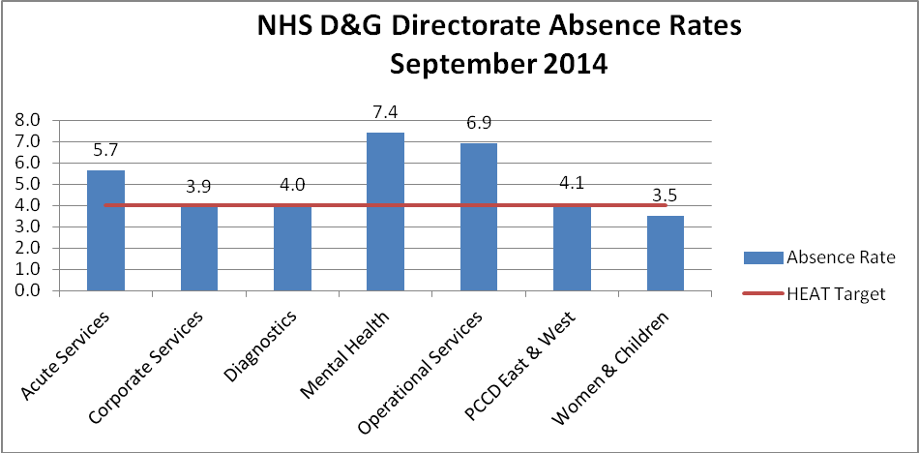

Long/Short Episode Breakdown – NHS D&G September 2014

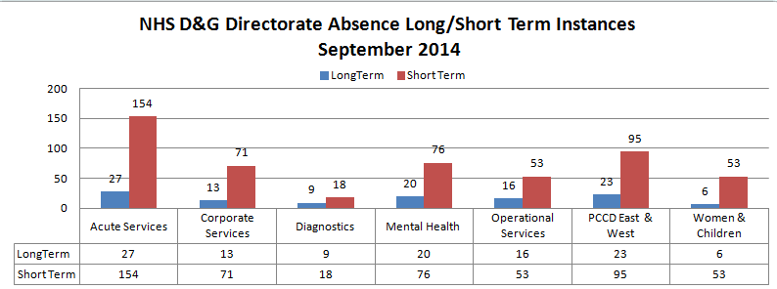

6. eESS UPDATE

- National Pilot Plan – Three boards are working with the national team to implement eESS fully end to end. The three boards are NHS Lanarkshire, NHS Lothian and National Services Scotland. Estimated to be complete by March 2015.

- Reports – A further three boards are supporting testing of standard reports within the system - NHS Highland, NHS Borders and National Waiting Times Centre.

- Learning and Development Module (OLM) – interface with Learnpro switched on locally after testing nationally

- National SSTS/eESS Interface – SSTS interface switched on locally for Workforce Directorate week of 14/11/14 following extensive national testing period

- Data – local work continuing to ensure eESS data is current, including changes, new starts and leavers.

If you have any questions about how eESS will work please drop us an email dg.eess@nhs.net

7. EQUALITY & DIVERSITY

Scenario:

Andy’s employer brings in a new shift pattern which means that everyone has to work fewer days, but longer hours each day. Andy has a disability which means he is exhausted after two long days of working.

1) Can Andy challenge the introduction of the new shift pattern?
2) If so what provisions of the Equality Act would he rely on?
3) What should his employer have done before introducing the change?

Please see Appendix for the answer.

8. MODERN APPRENTICES

NHS Dumfries and Galloway provide Modern Apprenticeships each year in Business & Administration. We recently recruited 20 young people for the 2014/15 cohort, a similar number to previous years. Benefits for the young people include training, work experience, and a qualification. A high proportion gain permanent posts within the Organisation.
The cost to NHS Dumfries and Galloway is relatively modest for each Modern Apprentice, with a training wage of £110 per week provided in the first year. Each placement provided attracts £2,000 funding which helps offset training costs. The costs may vary depending on a number of criteria.
Our new group of Apprentices for 2014/15 are based in Gardenhill; Midpark Hospital; Primary Care Development; Dalbeattie Surgery; Patient Services and Communication; IT; Estates/Switchboard; Dept of Nursing; Smoking Matters; Speech & Language Therapy; Haematology; DGRI Labs; Medical Secretarial Unit; Annan Clinic and the Locality Offices, Stranraer. We wish them all good luck with this exciting opportunity and for their future career.

Please contact the Workforce team if you are interested in providing a Modern Apprentice placement in future.

9. RETIREMENT POLICY

The Retirement Policy has been updated – the main change is that the Retirement Form has been renamed and is now called the ‘Retirement Planning Form’.

In June 2014 colleagues in payroll requested a change to the form as some employees are currently led to think that by completing the Retirement Form they do not require to complete a separate Scottish Public Pensions Agency (SPPA) form. This leads to delays with the individual receiving their actual pension on retirement. The request was for Question 8 to be tweaked - taking out the existing details and reminding the individual that an SPPA form also requires to be completed 4 months prior to retirement.

10. ADVERSE WEATHER

With winter approaching all managers and staff are reminded of our Adverse Weather policy.

Employees should be reminded that as NHS is an essential service staff are expected to make every effort to attend work during periods of adverse weather.

Managers should ensure that they have robust reporting procedures in place during periods of adverse weather and that business continuity plans are up to date.

Where weather conditions are so extreme that an employee is unable to attend work managers can :

- Reallocate days off.
- Allow staff to use Flexitime/Annual Leave.
- Allow staff to use annual leave from the following leave year when entitlement is exhausted from current leave year.
- Allow staff to work time back at mutually agreed time.

Where none of the above are possible unpaid leave should be granted.

Communication is key and any staff who do not notify the manager prior to the commencement of their shift may have payment for that shift withheld as per the Attendance Management policy.

11. OCCUPATIONAL HEALTH

Dyslexia Awareness Week - 3-7 November 2014
You may have noticed recent information regarding the above on communication boards throughout the organisation, or read the recent Blog which gave an account of a NHS D&G employee’s experience living and working with this condition.
It is estimated that 1 in 10 people are dyslexic. Unfortunately it can often be undiagnosed and undetected. It is a hereditary, life long, neuro developmental condition and is classed as a disability under equality legislation. Unidentified dyslexia can result in low self esteem, high stress, behavioral problems and low achievement. The impact of dyslexia as a barrier to learning varies in degree according to the learning and teaching environment, as there are often associated difficulties. Once diagnosed/detected much can be done to support those experiencing difficulties.
Further information can be accessed on the link below. However if an employee wishes to discuss a query in confidence they should contact OH.
See www.dyslexiascotland.org.uk for further information
Respiratory Mask (FFP3) Fit Testing
As you are aware the winter season is upon us and the opportunity is being taken to stress the importance to staff, working in high risk areas that they must be fit tested for FFP3 respirator masks.

Please note that there is a new 8835H version which comes in one size only. This replaces the 8835 small/medium and 8835 medium/large.

This means staff previously fit tested for 8835 small/medium must be fit tested with the 8835H.

Staff previously fit tested for the 8835 medium/large can consider their previous result valid for the 8835H version and do not require to be re fit tested.

There may be some old stock in circulation but would expect these supplies to be running low. New stock will be the 8835H version.

If you have any queries or concerns regarding fit testing please do not hesitate to contact Heather Aitchison at Occupational Health Ext 34626.

Give Your Hands a Hand
The first barrier to infection is a healthy intact skin.
Be kind to your skin and it will be kind to you.
Did you know that the skin on your hands is thinner than on most parts of the body and has fewer oil glands? That means it's harder to keep your hands moist, especially in cold, dry weather. This can lead to itchiness and cracking.
Some tips:
- Use alcohol liquid/gel to decontaminate hands as this is kinder to your skin.
However if :
- Hands are visibly soiled or dirty; or
- You are caring for a patient with a suspected or known gastro-intestinal infection e.g. norovirus or a spore-forming organism such as Clostridium difficile.
Hands must be washed with non-antimicrobial liquid soap and water.
- If wet working wear gloves
- Don’t forget give your hands a drink, moisture with a water based moisturiser 5-6 times a day especially at break times.
- If your skin is very dry cream/moisturise at night and cover with cotton gloves or polythene gloves- encourages absorption of creams- oil based protect cream.
- Wear gloves outside in cold weather.
- At home wear gloves for all wet work, e.g. dish washing, laundry and cleaning.
- People with children under 5 are more likely to have skin problems due to the amount of ‘wet work’, be extra careful if this is you, wear gloves and moisturise frequently at home as well as work.
- Use nitrile gloves not latex, latex gloves should only be used if a risk assessment deems them necessary. If you do use latex gloves regularly ie, daily you should have annual Health Surveillance.( see latex policy)
- If you are supplied with alternative hand hygiene or care products you should have received a card from Occ Health which you should carry with your ID badge and remember the products are for your use only.
- Occupational Health can as a temporary measure recommend the use of Cotton glove liners. These must be single use only.

It is important that If you develop or have any redness, rash, itchy or broken skin or any other skin concerns that you contact Occupational Health as soon as possible to seek the appropriate advice/recommendations.
Ext 34626 Mon to Fri 08:30 to 16:30 excl Public Holidays

The Workforce Directorate would like to wish you all a very Merry Christmas and a Happy New Year

Appendix

ANSWER

1) Can Andy challenge the introduction of the new shift pattern? - Yes he can. It is potentially discrimination arising from a disability.
2) If so what provisions of the Equality Act would he rely on? - The employer would need to explore the possibility of making reasonable adjustments to Andy’s shift pattern.
3) What should his employer have done before introducing the change? - If the employer had undertaken an Equality Impact Assessment then this type of issue would have been flagged up and adjustments could have been made before it became an issue.

